Toolbox Topic: Masculinity and Emotional Literacy (Worked Example)

Opening the Conversation
Complete

Superficial Discussions
Gender Box is an activity that is found in many toolkits and encourages you to facilitate discussions around stereotypical social constraints put on boys/men, girls/women.

Start by sorting your group into 2 smaller ones, then lead a discussion to make sure everyone knows what a stereotype is.

It would be a good practice recommendation to have your ground rules displayed or revisited verbally, ensuring confidentiality and ‘not naming names’ is set as a reminder.

Start by giving one group a piece of flipchart paper and ask them to write 'Male' in the middle of their sheet, then hand the remaining flip chart sheet to the other group and ask them to write 'Female' in the middle of theirs.

Ask the participants to think of and list words/phrases on their subsequent pieces of paper, making sure they cluster words in the middle of the sheet, listing stereotypical messages they receive from culture, including TV, Social Media and advertising. Make sure they don't include their own personal examples.

Examples may include (Female sheet) “Pretty (prompt to explain what being pretty means), big boobs, perfect, pink, nice skin, skinny, tanned”. (Male sheet) “Tuff, strong, the breadwinner, not gay, blue, earn more money, buff”.

When they have done this, ask them to draw a box around the words they have in the middle of their sheet, then ask them what words/phrases may be used if you don't 'conform' to what's in the box.

Ask for feedback once this has been done and explore findings by asking some questions, such as, what do the words in the box have in common? (most of them will be negative towards women 'Slag, bitch, hoe, lesbian, gay, pussy' etc). Explore how people are kept in their boxes (peer pressure, wanting to fit in etc).

Once you feel enough chat has taken place, ask the group to think about and share what might happen if someone tried to come out of their box, this is where subjects such as bullying, substance abuse and suicide may arise which will allow you then to progress the discussion into the 'Deeper' element of the framework.

You can consolidate learning by showing this clip...
https://www.youtube.com/watch?v=CWvXal1L5U4

Another useful element to doing this activity is that as a ‘Facilitator’ you are more than likely to hear slang words young people are using in their everyday language that you have no idea of!

This exercise works well as a peer education exercise.

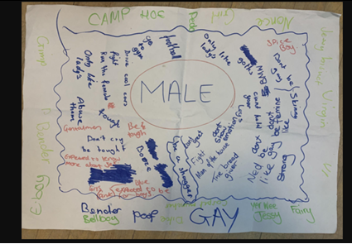
To help you see how Gender Box looks in 'real life, here are some pictures from when the peer educators involved in this project completed the activity
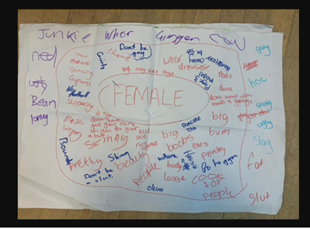

Superficial Continued…

Using Music

A lot of discussions with young boys in particular, can be had if you listen to what they are listening to. You could listen to the lyrics of songs and help them critique what they are listening to? Rap, Hip Hop, Grime and Drill are genres in particular that are known to be violent and derogatory towards women, some of the words young people may have identified while doing the Gender Box activity are mentioned frequently.

When this has been done in the past it has been noted that younger boys sing along and when asked, have no idea what words like 'hoe' 'bitch' 'pussy' mean. If music is used as a tool it may allow young people to gain perspective, stand and take stock around how this language can infiltrate and harm the everyday conversations they are having with others.

This is a trailer for a film made to address masculinity in Hip Hop culture, produced in 2006.

Watch the trailer from the documentary ‘Hip Hop - Beyond Beats’ and think about how relevant this is to society today? Have things got better? or worse? Who do you think makes the money from the lucrative 'Hip Hop' industry, men or women?

https://shop.mediaed.org/hip-hop-p103.aspx?Thread=True

Media in General…

It's vital we as youth workers have a critical awareness of the media when we are discussing GBV. This is because current popular culture has become 'hyper sexualised' and 'pornified', meaning that boys/men are facing increasing pressure to 'stay in their box', to be 'dominant, powerful, tuff', while girls and women are pressured to be and look 'sexy, hot, young, submissive, and have perfect bodies'.

This is adding to an already significant power imbalance between binary genders that is extremely toxic. This culture shift has also been very insidious and young people now think this power imbalance is normal. This is because 'sexualised' imagery is everywhere they are.

The correlation between 'Pornification' and the Media will be explored a bit more 'Pornography' session.

Watch the clip below for info. The clip is also useful for initiating discussions about where some of the 'stereotypes' young men conform to come from and who profits 'keeping boys in the box' (You may need to sign in to Vimeo to access)

https://vimeo.com/107911079

Deeper Conversations

