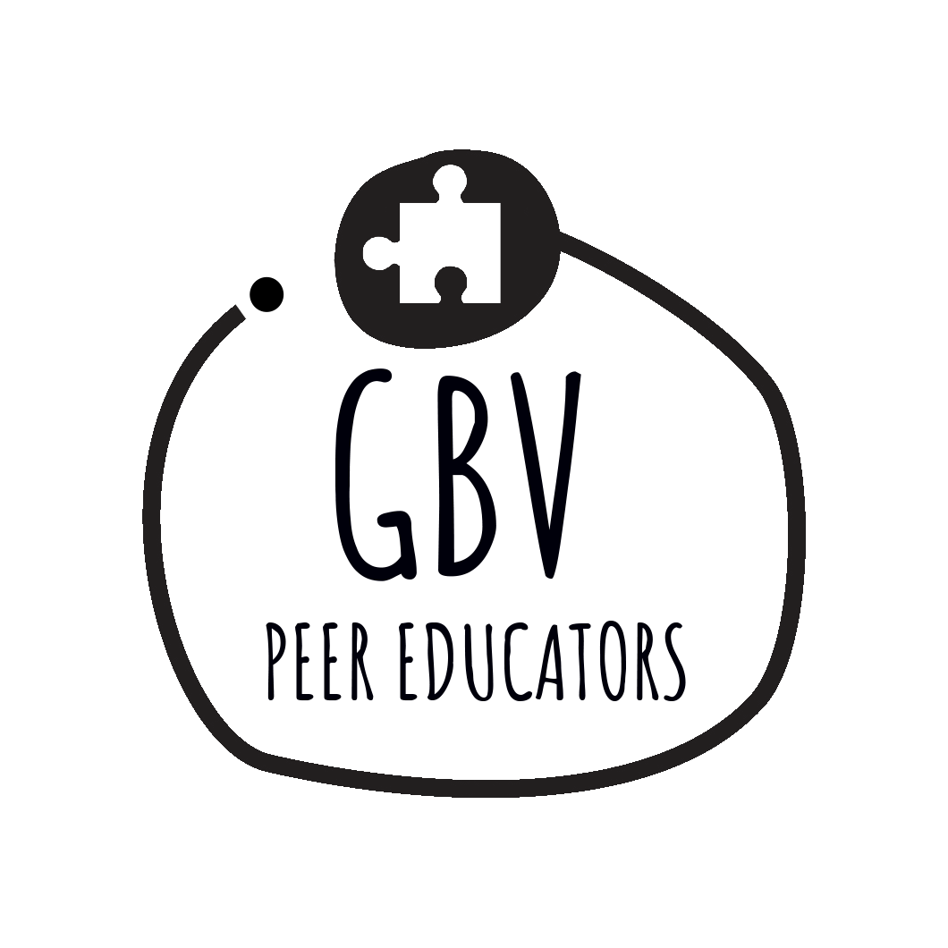


Beyond #MeToo, Youthworkers, Young and
the wider community making a positive change around GBV

Allies Game

A short and simple game to explain that some things can only be done with the help of others. Ask the participants to lie down on the floor. Then tell them to lift their whole body slightly off the floor, just a little bit, but that no part of the body should touch the floor. More often than not, participants will have a think and then look at you questioning your sanity.

Admit to them that of course, this is not possible. Then have them get together in groups, maybe 5 in a group, and that only one of them has to lie on the floor and whether they can then find out how to lift that person off the floor a little. They won’t have any problems with that.

From there you can take a number of discussion points:
- The difference between trying this exercise alone or with others is not too different from trying to deal with the consequences of violence alone or having allies to help.
- The task is easy for a short time, but if you ask 4 young people to hold a friend for an entire evening, it will be quite difficult. The number of allies is important.
- Ally tasks can be different, both in what they are and how long a person needs you. Discuss how they can be different.
- People's reasons for being allies can vary, what could be the reasons?

