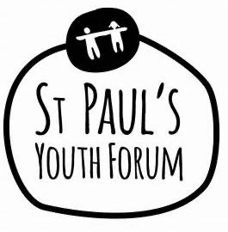

Beyond #MeToo, Youthworkers, Young People and
the wider community making a positive change around GBV

Toolbox Topic: Masculinity and Emotional Literacy (Worked Example)

Opening the Conversation
Word Association Games
This TedTalk from Youth Worker Ben Hurst will explain how word association games can be an excellent tool to open discussions…
https://www.google.com/search?q=ted+talk+ben+hurst&oq=TedTalk+Ben+hurst&aqs=chrome.1.69i59j0i13j0i8i13i30.10687j1j7&sourceid=chrome&ie=UTF-8
Watching the whole TedTalk (Ten Mins) will be useful for context, however Ben talks about the game specifically at 2min 30.

A to Z of emotions game
Either use pre-made sheets or simply ask the group to list the alphabet from A-Z, then give 5 minutes to allow everyone to write one emotion for each letter.
Get the group to feed back their suggestions.
*Note: The practitioners who came together as part of this project and have facilitated this game, shared that they noticed gender differences in answers, such as girls tend to use more negative words to boys, and also take longer. If this happens with your group, this may be something that can be taken forward to the next part of the conversation.
Fact Finding* and Quizzes
You, yourself could make up a quiz or even ask some of your young people to make one.
Facts are a useful tool to help raise awareness of subjects that may have 'grey' areas or hold a particular un-useful set of attitudes and values held by a group of young people you are wanting to challenge. Such as, the fact violence is predominantly perpetrated my men towards women, or the fact that boys/men are more likely to complete suicide.
Quizzes are often used in training sessions to 'scene set' and present the 'issue' as an issue.
*Always make sure your facts come from a reliable source.
Here's an example of statistics you could turn into a multiple choice set of questions.
https://ukmensday.org.uk/key-facts/

Superficial Discussions

Deeper Conversations

