
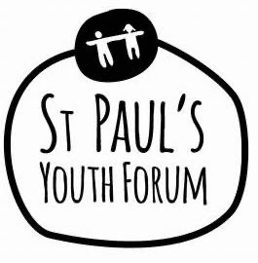

Beyond #MeToo, Youthworkers, Young and
the wider community making a positive change around GBV

Fact-Finding Quizzes

You, yourself could make up a quiz or even ask some of your young people to make one.

Facts are a useful tool to help raise awareness of subjects that may have 'grey' areas or hold a particular un-useful set of attitudes and values held by a group of young people you are wanting to challenge. Such as, the fact violence is predominantly perpetrated by men towards women or the fact that boys/men are more likely to complete suicide.

Quizzes are often used in training sessions to 'scene set' and present the 'issue' as an issue.

*Always make sure your facts come from a reliable source.

Here's an example of statistics you could turn into a multiple-choice set of questions.

https://ukmensday.org.uk/key-facts/

